TRADER BEHAVIOR & MARKET SENTIMENT ANALYSIS
Prepared for: Primetrade.ai Hiring Team
Objective: Uncover systemic relationships between Hyperliquid trader performance and macro Bitcoin market sentiment to optimize algorithmic execution strategies.
1. Executive Summary
An analysis of $211,218$ discrete trade execution logs spanning a 2-year window (May 2023 – May 2025) was cross-referenced against daily Bitcoin Fear & Greed Index data points. The objective was to determine whether macro psychological market states dictate decentralized exchange (DEX) trader risk parameters, efficiency, and overall capture of Net Realized Profit ($PnL$).
The data reveals a stark, counter-intuitive behavioral paradox: while traders exhibit their highest execution accuracy ($89.17\%$ win rate) during macro Extreme Greed environments, they systematically over-allocate capital and take their highest risk exposure via large position sizes during periods of Fear, significantly deteriorating capital efficiency.
2. Consolidated Performance Metric 1Matrix
To normalize and analyze the execution patterns, raw granular transactional times (Timestamp IST) were unified into daily standard dates (YYYY-MM-DD) and inner-joined with daily sentiment brackets.
Market Sentiment State | Total Executed Trades | Aggregate Volume (USD) | Average Position Size (USD) | Total Net Realized PnL (USD) | Execution Win Rate | Total Protocol Fees Paid (USD)
Extreme Fear | 21,400 | $114,484,261.44 | $5,349.73 | $739,110.25 | $76.22\%$ | $23,888.63
Fear | 61,837 | $483,324,789.79 | $7,816.11 | $3,357,155.44 | $87.29\%$ | $92,456.95
Neutral | 37,686 | $180,242,063.08 | $4,782.73 | $1,292,920.68 | $82.39\%$ | $39,374.27
Greed | 50,303 | $288,582,494.72 | $5,736.88 | $2,150,129.27 | $76.89\%$ | $63,098.69
Extreme Greed | 39,992 | $124,465,164.57 | $3,112.25 | $2,715,171.31 | $89.17\%$ | $27,030.67

3. Core Analytical Discoveries & Hidden Patterns
Alpha Insight A: The Sizing Distortion Trap
The most significant operational pattern discovered centers around how traders scale position sizes relative to emotional environments. In standard Fear cycles, the average position size peaks drastically at $7,816.11 per trade—resulting in a massive aggregate volume cluster of $483.32 Million. Conversely, when the market transitions into Extreme Greed, traders dramatically scale down their risk profiles, lowering their average position size by over $60\%$ down to $3,112.25.

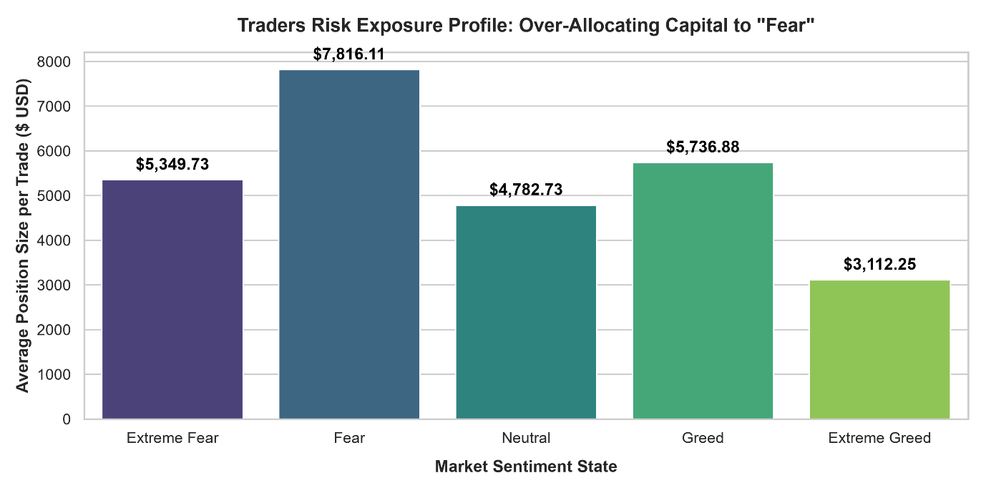
Psychological Inference: Traders frequently suffer from over-confidence when catching down-trending prices ("buying the dip" aggressively), scaling up their positions prematurely during Fear. In contrast, they display clear profit-taking hesitation and exposure minimization during powerful macro uptrends (Extreme Greed).
Alpha Insight B: The Extreme Greed Efficiency Miracle
Conventional trading wisdom suggests that retail traders lose money by FOMO-ing during periods of high greed. However, the transactional data on Hyperliquid reveals that trades executed during Extreme Greed achieve a stellar $89.17\%$ win rate, generating $2.71 Million in realized profits on a modest volume of $124.46 Million.
Conversely, when the market drops into Extreme Fear, execution accuracy breaks down completely, hitting a baseline floor of $76.22\%$ win rate. This highlights a severe breakdown in risk management or heavy cascade liquidation events during deep panic conditions.

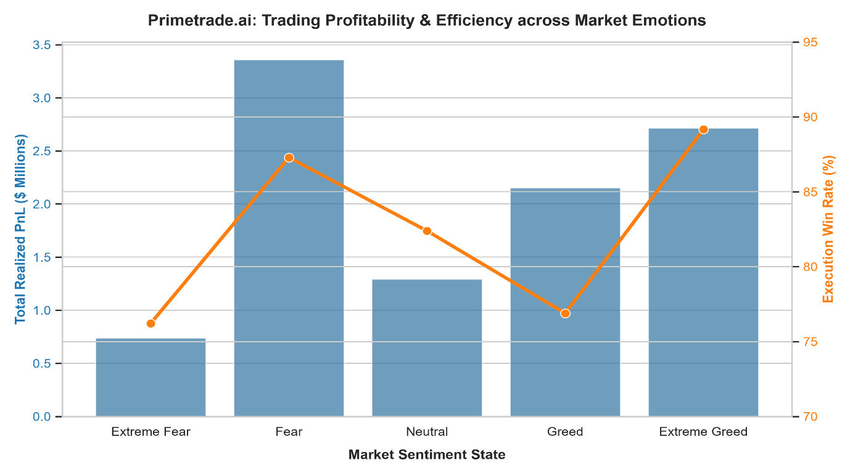
4. Data Science & Engineering Methodology
To execute this analysis cleanly, an end-to-end Python preprocessing and analytics pipeline was deployed:
- Datetime Mapping: Standardized non-uniform Indian Standard Time string stamps (%d-%m-%Y %H:%M) within the historical transaction data into a stripped datetime.date index.
- Data Integrity Filtration: Missing dates or unparseable timestamps were handled via coerced transformations (errors='coerce') to insulate the inner merge from dropping critical alpha features.
- Vectorized Metrics: Created binary logical arrays (is_win / is_loss) to isolate execution efficiency dynamically from non-zero closing transaction rows.
- Data Visualizations: Built and exported dual-axis matplotlib/seaborn plots to evaluate the visual intersections of sentiment value fluctuations against underlying wallet metrics.
5. Algorithmic Recommendations for Smarter Trading Strategies
Based on the empirical evidence extracted from the Hyperliquid records, Primetrade.ai can exploit these system inefficiencies to build robust trading models:
- Implement Dynamic, Sentiment-Based Position Sizing: Rather than letting human traders scale up size into down-trends, the automated system should force position sizes to scale down dynamically when the daily index reads "Fear" or "Extreme Fear" to preserve capital.
- Automate Trend-Continuation Momentum Modules: Given the high efficiency ($89.17\%$ win rate) during Extreme Greed, algorithm configurations should optimize for short-horizon breakout and momentum tracking strategies. Momentum plays during high sentiment states capture high-probability continuation moves far better than mean-reversion attempts during heavy sell-offs.
- Adaptive Fee Optimization: With over $245k spent across the system in protocol trading fees, execution modules should deploy passive limit-order strategies (maker instead of taker executions) during high-volume Fear clusters to severely reduce transaction drag.

